CSCI313/ECEN428: Software Engineering
Software Requirements Specification
(SRS DOCUMENT)

for
<Airline Reservation System>
Version 1.0
December, 2022
Mobile Application
*Submitted To*
Dr. Walaa Medhat Asal
By
Mazen Mohamed Abdalla 202000894
Ahmad Mustafa ElSaid 202001536
Seif Eldin Wael Samir 202002249
John Anwar shaker 202001120
Mazen Sarwat 19104691

Table of Contents
1. Introduction 3
1.1 Purpose of the document 3
1.2 Scope of the project 3
1.3 Technologies Used 3
1.4 Intended Audience 3
1.5 Overview………………………………………………………………………………………….. 3-4
2. Overall Description ….……..…………………………………………………………………………. 4
2.1 Product Perspective ………………………………………………………………………………... 4
2.2 User Characteristics …………….…………………………………………………………………. 4
2.3 Operating environment ………………………………………………………………….………… 5
2.4 Constraints ………………………………………………………………………………………… 5
2.5 Assumptions and dependencies …………………………………………………………………… 5
3. Interfaces ……………………………………………………………………………………………… 6
4. Functional Requirements …………………………………………………………………….…..…. 14
5. Non-Functional requirements ………………………………………………………………………. 15
6. Diagrams ………………………………………………………………………………….…………. 16
6.1 Use case diagram ………………………………………………….………………………...…... 16
6.2 Use case scenarios ……………………………….……………………………………...………. 17

Introduction

Purpose
This document provides a comprehensive overview of the Android application "Skies", which is used to make airline reservations. The system's overall description, interfaces, functional and non-functional requirements, and system diagrams will all be all covered. The previous parts will give a solid understanding of the functions carried out by the system, the usage scenarios, and the constraints that must be satisfied for the system to operate.

Scope of the project
The Android application “Skies” is an Airline reservations system which works as a mediator between the client and the airline's office to make reservations for air travel without requiring the client to visit the airline's office, saving the client time. The system has one types of users: regular users (Clients) who have registered with the system. After registering with system, the user can login and be allowed to Book a flight, cancel a booked flight, edit a booked flight, view all booked flights, view timetable of flights, add a bank account, track flight status, edit profile, and report/give feedback. The application is linked to the airline's office database to view customers the available flights and save their data, as well as to bank databases to provide the ability to pay booking costs and get refunds if a flight is cancelled.

1.3 Technologies Used
1 – Java programming language
2 – Android studio for mobile application development
3 – MySQL for databases

1.4 Intended Audience
The audience for this SRS is the customer who want to make use of the application's service. The developer who must implement a high performance and secure application that suits the user requirements. The software tester who must develop valid test cases for the application until it reaches the acceptance of the customer. The project manager, who will utilize the SRS to carry out his duties, which include creating a detailed schedule to finish the project in the allotted time.

1.5 Overview
The SRS's remaining sections include explanations of the "Skies" Application's precise requirements. Chapter.2 lists the broad elements, like project restrictions and user characteristics, that have an impact on the Application and its requirements. Chapter.3 illustrates the details of interfaces, and then the rest of the chapters' present the functional and nonfunctional requirements, Diagrams, and other related requirements of the application.

2. Overall Description

2.1 Product Perspective
Since "Skies" is an android-based application, an android device running on version 6.0 or higher is required. The app has a suitable user interface and is a self-contained, independent system. It will be able to establish a connection with a remote database server for the purposes of data storage, retrieval, and searching related to Clients, Flight information, and Reservation details. Clients are the only type of users who can use the system with certain functionalities.

USER
SERVER
DATABASE

Book a flight
cancel a flight
edit a booked flight
view all booked flights
view timetable of flights
add a bank account
track flight status
edit profile
report/give feedback

Simple Block Diagram for "Skies" Android Application

2.2 User Characteristics
The system has one types of users: regular users (Clients) who have registered with the system and want to make use of the service without engaging in the process physically in an airline office by booking / canceling / editing a booked flight and many other functionalities that are available through the interaction with the mobile application and will be discussed later in detail in the following sections.

2.3 Operating environment
The software being developed on Windows OS with the Android SDK using Android Studio will be deployed and run-on Android OS version 6.0 or above.

2.4 Constraints
- Android must be the operating system used by the application.
- The device of the user must provide network connectivity (WIFI).
- User’s must have an account on the application.
- Java and the Android SDK are for software development.
- MySQL database engine is used by the system.

2.5 Assumptions and dependencies
It is assumed that the users of the application have the following:
- Android version compatible with the application.
- Internet connection.
- An account on the application linked with a banking account.
The system is assumed to depend on a reliable database for the for the purposes of data storage, retrieval, and searching related to Clients, Flight information, and Reservation details.

3. Interfaces

Splash Screen:

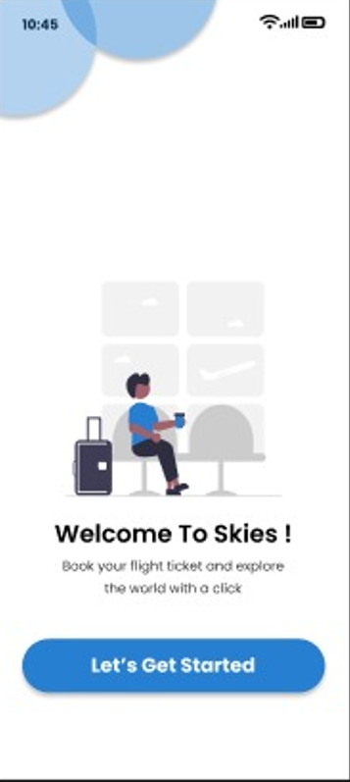

Login Screen:

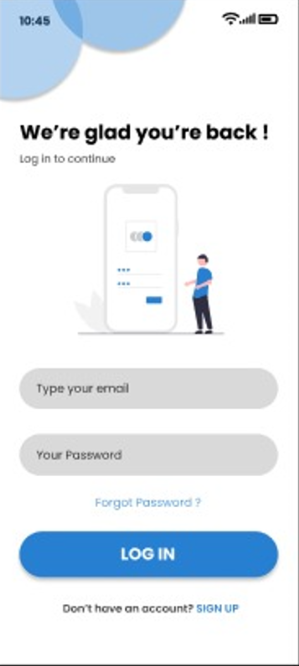

Sign Up Screen:

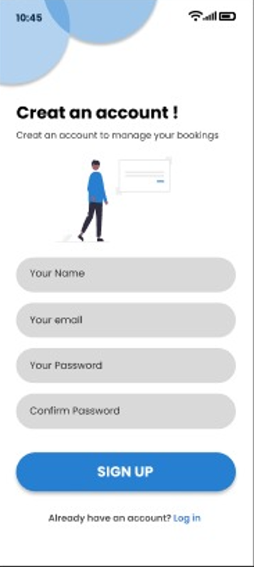

Recover Password:

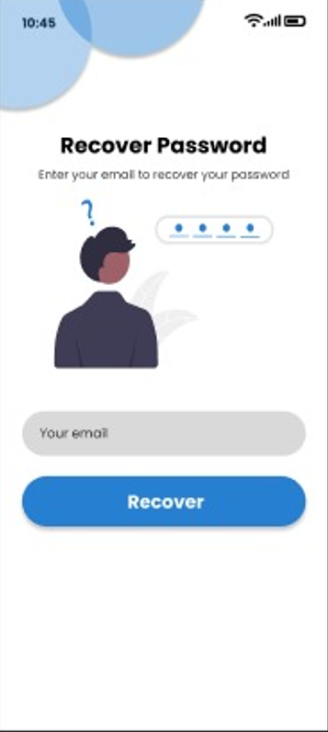

Search:
ROUND TRIP ONE WAY
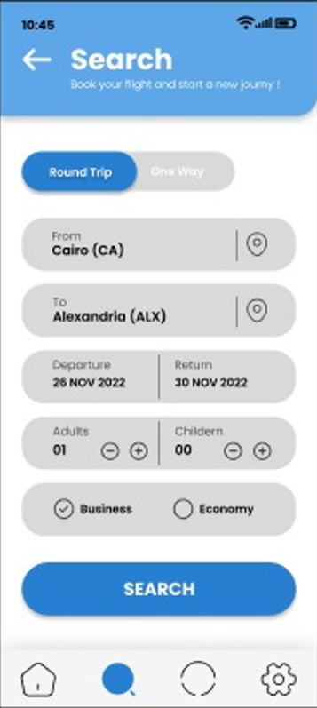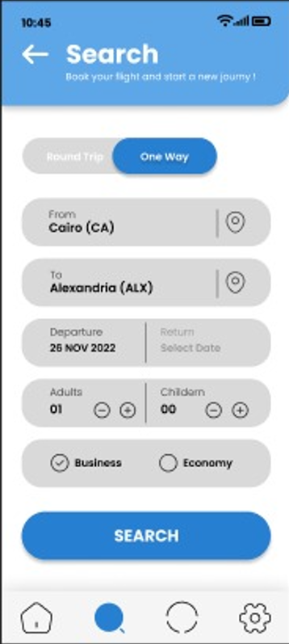

Choosing the Trip:

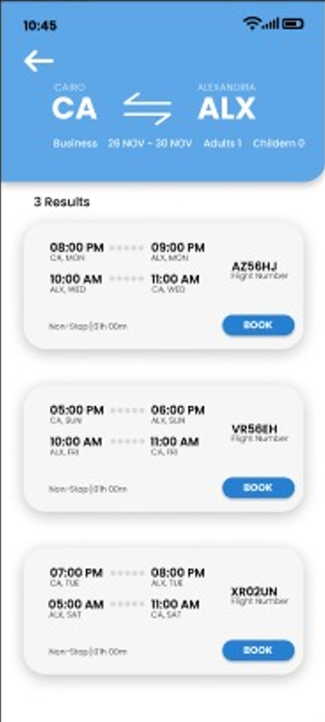

Status:

Flight Status FOUND NOT FOUND
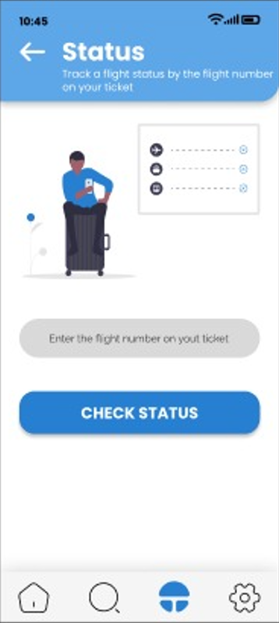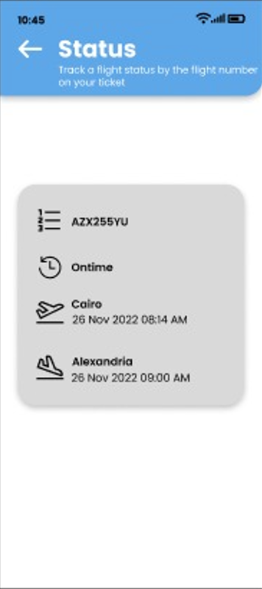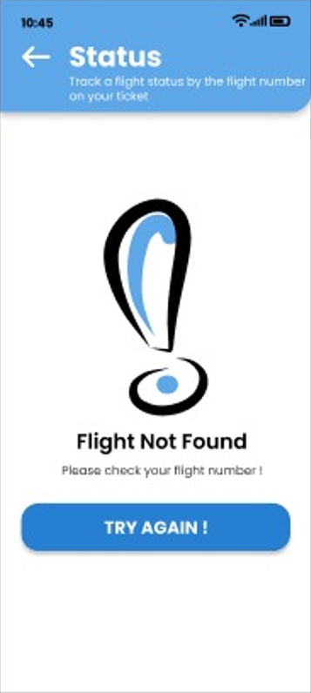

Credit Card Information:

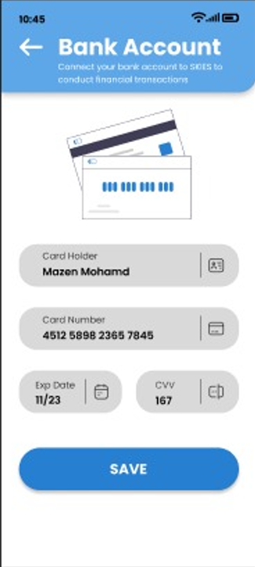

4. Functional requirements

4.1 Functional requirements
Title: User Login.
Description: System shall allow the registered users to login by providing a valid username and valid password.
4.2 Functional requirements
Title: Show Reservation.
Description: System shall display all available flights the system.
4.3 Functional requirements
Title: Book Flight.
Description: System shall allow user to enter his preferred booking schedule by choosing ticket types and processing online payment.
4.4 Functional requirements
Title: Cancel Booking.
Description: System shall allow user can request the cancellation of the reserved ticket maximum by 12h.
4.6 Functional requirements
Title: View Booking.
Description: System shall display all his previous booking data with a counter for the upcoming flight.
4.7 Functional requirements
Title: add banking detail.
Description: System shall prompt the user to add his banking detail.
4.8 Functional requirements
Title: Track Flight Status.
Description: System shall display the booked flight statues(cancelled ,changed flight time or still the same).
4.9 Functional requirements
Title: Edit Profile.
Description: System shall allow user to change his information (user data, name, bank account).
4.10 Functional requirements
Title: Report/Give Feedback.
Description: System shall display pending questionnaire for the user to give his feedback.

5. Non-Functional requirements

5.1 Performance rate.
- System should be able to handle 1000 transactions per second.
5.2 Reliability Requirements.
- Maximum 3 online payment transactions through the systems can result in failure.
5.3 Security Requirements.
- Customized password should be at least 8 characters.
5.4 Maintainability Requirements.
- User should be displayed acceptance message within 5 seconds, when he/she submits entered data to the system.
5.5 Portability Requirements.
- System should be manageable android 6.0 while being lightweight mobile application.
5.6 Safety Requirements.
- System should assure data integrity.
5.7 Safety Requirements.
- System should include restore and recover functions to prevent data loss.
5.8 Safety Requirements.
- The application should be platform independent.

4. Diagrams

4.1 Use case diagram

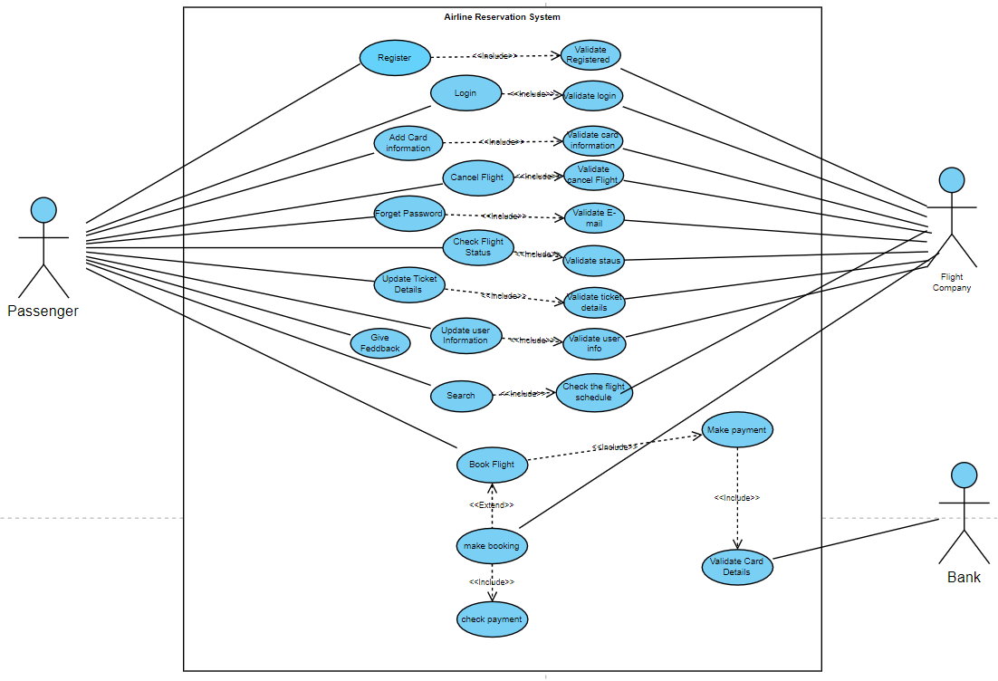

4.2 Use case scenarios

Use case 01
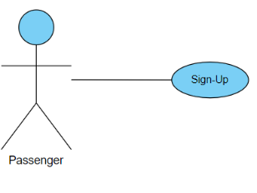
Sign-Up
Usecase Name | Sign-Up
Actors | Passenger (Non-registered).
Main success scenario: | - The system asks for an e-mail address and password, or the user can register for a new account.  - The user selects registration.  - The System prompts user for registration information, Name, E-mail, password, Confirm password.  - The user provides the required information.  - User clicks on submit button (Sign Up)  - System checks if the username is not already in use.  - System verifies information and creates account.
Exceptions | 4a. User clicks submit without entering the required information that the system asked for.  6a. The E-mail already exists in the system.
Actions | - System display error alert to the user "Information required".  - User refill required info.  - System asks the user to Login "Username already have an account".
Pre-condition | - User has registered successfully.
Post condition | - Number of users of the system is increased by 1  - User is successfully registered  - Login info is stored in the DB

Use case 02

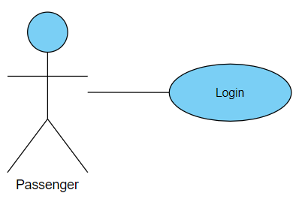
Sign-Up
Usecase Name | Login
Actors | Passenger.
Main success scenario: | - System displays login page for User (Passenger) and requires E-mail and password.  - User provides the E-mail and valid password.  - User clicks on submit button <Login>.  - System validates the User E-mail and password and logs him/her into the system.
Exceptions | 2a User typed invalid E-mail or invalid password.  3a User tried to login with an empty field.
Actions | 2.1 System displays an error message like "Invalid E-mail OR Password, Please Try again".  2.2 User retries to login OR cancels operation.  3.1 System displays an error message like "please enter your E-mail/password".  3.2User retries to login OR cancels operation.
Pre-condition | User has an account.
Post condition | - The User (Passenger) is logged in to the system.  - The User has access to the functions (For Passenger) of the system.

Use case 03

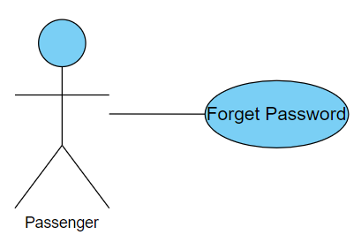
Sign-Up
Usecase Name | Forget Password
Actors | Passenger.
Main success scenario: | - System displays Recover password page for User (Passenger) and requires E-mail.  - User provides valid E-mail.  - User clicks on submit button < Recover >.  - System validates the user's E-mail address and sends the password to him/her via E-mail.
Exceptions | 2a User typed invalid E-mail.  3a User tried to Recover with an empty field.
Actions | 2.1 System displays an error message like "Invalid E-mail, please enter the correct e-mail".  2.2User retries to Recover OR cancels operation.  3.1 System displays an error message like "please enter your E-mail ".  3.2 User retries to Recover OR cancels operation.
Pre-condition | - User has an account.  - User cannot logged in.
Post condition | - The User Recovering him/her password.  - The User (Passenger) is logged in to the system.  - The User has access to the functions (For Passenger) of the system.

Use case 04
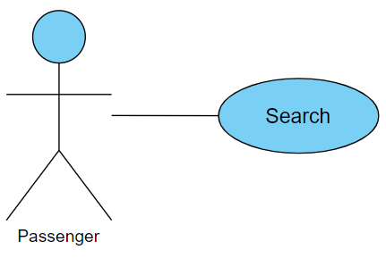
Sign-Up
Usecase Name | Search
Actors | Passenger.
Main success scenario: | - User selects One-Way OR Round-Trip.  - The System prompts user for trip details such as the Departure (From), Destination (To), Departure Date, Return Date (if Rounded Trip), etc.  - The user provides the required detail.  - User clicks on submit button <SEARCH>.  - The system checks the available flight schedules.  - System display results.
Exceptions | 4a User tried to Search with an empty field.  5a User searches for flights that are not currently available.
Actions | 4.1 System displays an error message like "please complete flight details ".  4.2 User retries to Research OR cancels operation.  5.1 System displays an error message like "your search is currently unavailable ".  5.2 User search in different details OR cancels operation.
Pre-condition | User logged in.
Post condition | - The user has access to all the results corresponding to his/her search.  - User can access all flights details.

Use case 05
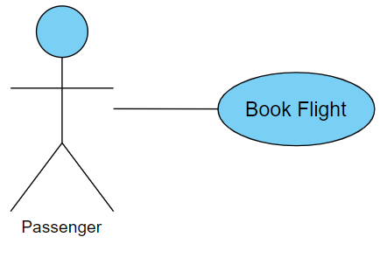
Sign-Up
Usecase Name | Book Flight
Actors | Passenger.
Main success scenario: | - User choose the flight wants to book.  - User clicks on book button <BOOK>.  - System validates the user's card balance.  - System verifies(confirm) card balance.  - System withdrawals funds of the flight from the user's account and books the flight.
Exceptions | 2a The user has not added a credit card.  4a User does not have enough balance.
Actions | 2.1 the system will display Bank Account page add card information then check balance.  2.2 User add card information OR cancels operation.  4.1 System displays an error message like "Please, add enough balance too book your flight ".
Pre-condition | -User logged in  -User have an account..
Post condition | User booked his/her flight successfully.

Use case 06
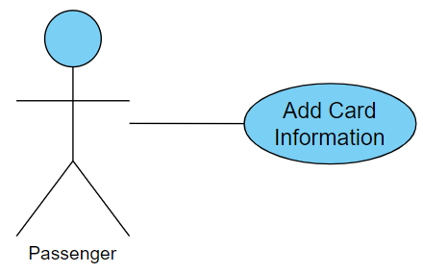
Sign-Up
Usecase Name | Add Card information
Actors | Passenger.
Main success scenario: | - System displays Bank Account page for User (Passenger) to add card information and requires Card holder, Card number, Exp date, Card verification value (CVV).  - User provides the required information.  - User clicks on submit button <SAVE>.  - System validates the Card information and saves in DB.
Exceptions | 2a User type invalid information like CVV, etc.  3a User save without data or data missing
Actions | 2.1 System display error message like “Please, enter valid CVV, etc.”  2.2 User retries enter the correct data or cancel operation  3.1 System display error message like “Please, enter valid Card number, etc.”  3.2 User retries to add the missing information or cancel operation
Pre-condition | User logged in.
Post condition | - The User (Passenger) added credit card to the system.  - The User has access to book flight.

Use case 08
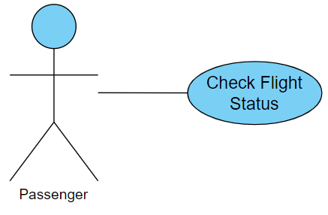
Sign-Up
Usecase Name | Check Flight Status
Actors | Passenger.
Main success scenario: | - User clicks on status page icon to open.  - System displays status page for User and requires flight number in his/her ticket.  - User clicks on submit button <CHECK STATUS>.  - System validates the User flight number.  - System switch to another status page and display flight information.
Exceptions | 2a User typed invalid flight number.  3a User tried to check flight status with an empty field.
Actions | 2.1 System display flight not fount page and display error message like “please, check your flight number !” and asks user to try again.  2.2 User retries to enter correct flight number OR cancels operation.  3.1 System display error message like “please, enter your flight number”  3.2 User retries enters a flight number OR cancels operation.
Pre-condition | User logged in.
Post condition | User view his/her flight status.

